University of Michigan
Master of Applied Data Science Program
Fall 2025 SIADS 699

Optimization of Urban PV Installation
Erin Mettler, Ruchi Patil, Stephanie Maciejewski

Introduction
Electricity has been commonplace in American homes since the early 1900s (LaRiccia, 2025), and in recent years, Americans have increasingly been turning to electricity as their primary power source for home heating and cooling (U.S. Energy Information Administration, 2025). As households continue to electrify their appliances and the cars that they drive, and as data center construction and electricity consumption increases at an ever faster rate each year, city planners and utility executives are faced with an increasingly difficult question to answer: how can we meet growing electric demand in a way that is faster and more affordable than buildout of traditional energy infrastructure?
Large scale renewable energy sources including ground-mounted solar panels and wind turbines are some of the most cost effective methods of clean electricity generation. However, these sources require land and ground space which is often limited in and around cities that are experiencing large amounts of electric load growth due to land-use laws and zoning provisions. These projects frequently face opposition from nearby residents who take “not in my back yard” positions due to their land use, visual obstructions and general appearance, and noise output. This opposition can slow, or even block, the construction of these electric generation technologies. Existing rooftops represent a massive, and largely untapped, opportunity for distributed solar generation. National studies of rooftop solar potential suggest that roughly 95% of solar-generation-suitable rooftops remain unused, even in cities with relatively high adoption of solar photovoltaic (“PV”) panels (O'Shaughnessy et al., 2021). Turning rooftop “dead space” into distributed energy resources could help cities meet growing electric load, while also relieving pressure on overburdened transmission and distribution systems. Several tools already exist to help estimate rooftop solar potential and guide project developers and policymakers. For example, Google has developed rooftop solar “sun maps” that identify where solar is likely to be viable on individual buildings (Google, 2021). These tools are invaluable for advancing consumer knowledge about solar energy production, but they can be difficult for laypeople to understand how to operate.
Our project builds on this existing solar potential ecosystem, but aims to meet a different need than existing tools. Instead of providing a solar potential analysis for a single rooftop, we focus on using computer vision and supervised learning via CNN models to systematically identify rooftops in high-resolution satellite imagery of entire zip codes, estimate how many PV panels each roof can host, and translate those results into estimates of how much of a city’s current and future electric demand could be met with rooftop PV. Ultimately, this product can give cities and utilities a more concrete and spatially-specific picture of where they can place distributed rooftop solar, and the optimal locations to do so to meet given capacity needs.
For Ann Arbor, our model estimated that 3.12e6 m² of available rooftop space with 8360 PV panels would be needed to meet residential electric demand at an estimated total cost of $9.35 Million. For Tucson, the model estimated that 1.85e6 m² of available rooftop space hosting a total of 4.69e6 PV panels would be enough to meet the city’s current electricity demand, at an estimated cost of $524 Million. With this increased information about rooftop PV potential, local governments and utilities can design more targeted PV adoption incentive programs, prioritize PV upgrades in locations that provide the most solar potential, and compare rooftop PV and behind-the-meter storage investments (such as on-site battery storage) directly against traditional electric utility infrastructure solutions when planning for load growth.

Project statement
This project aims to identify how many, and which, rooftops hosting PV panels would most optimally meet a city’s energy needs or a user-specified capacity growth requirement. We estimate the potential cost savings from constructing optimal rooftop PV systems instead of traditional electric infrastructure, and we compare the timelines of rooftop PV deployment to the timelines of traditional grid buildout.

Methodology
As a minimum viable product (“MVP”) we planned to create a model that would analyze rooftop solar potential for existing rooftops in two cities: Tucson, Arizona, and Ann Arbor, Michigan. We selected these cities because they represent two very different climates, with Tucson being warm and arid (and having a corresponding high electric load for cooling, particularly in the summer months) and Ann Arbor experiencing high summer temperatures and very low winter temperatures (with corresponding cooling and heating loads in peak hot and cold months), allowing us to use these as proof-of-concepts for other cities and states. We established the following elements of a successful outcome for our MVP:
- A model that receives 256x256 pixel tiles of satellite images as an input, and as an output detects the rooftops and estimates the roof area within each of these images
- A model that provides a solar PV panel output potential for each identified rooftop, given a set threshold.
- An interactive and user-friendly Streamlit app that would enable a user to input any electric capacity amount in Megawatts (“MW”) and Kilowatts (“kW”), and receive as an output the optimal number of existing rooftops and corresponding PV panels needed to meet the user-input capacity need. These spatial resolutions were used to convert pixel counts into physical area and, ultimately, to create estimates of PV panel hosting and generation potential. As an additional stretch goal, this output would also include a visualization of the location of each of these rooftops.

To start, we hand-labeled over 2000 satellite images of rooftops, and used these labeled images to train a Convolutional Neural Network (“CNN”) model. While hand labeling training data is time consuming and resource-intensive, it provides a high-quality ground truth necessary for effective supervised learning, especially in image-based models where misclassifications can alter the rest of the models' analyses and performance. A CNN model was chosen because these models are good at image classification and don’t require manual feature engineering, making a CNN well suited for identifying and counting rooftops in satellite images, where rooftops can vary significantly in orientation, color, and surrounding imagery.

Our first CNN model was designed to detect rooftops in satellite imagery and use this information to assign an electric generation potential score to each rooftop. CNN models have been successfully applied in prior rooftop-solar potential tools like DeepRoof and Google’s Project Sunroof pipeline (Lee et al., 2019; Goroshin et al., 2023). We tested the performance of the CNN model using a set of satellite images that weren’t included in the training set, and evaluated the results using various metrics including F-1 scores, accuracy, and loss. This evaluation helps ensure that the model is learning generalizable patterns rather than simply memorizing the training data set.

In order to more accurately determine suitable rooftop space, we decided to progress from rooftop detection to drawing polygon masks around the detected rooftops. We used the You Only Look Once (“YOLO”) model, which uses a single CNN to divide a processing image into a grid for polygon segmentation. YOLO models are designed for fast and accurate object detection in images, and they are particularly effective in this scenario where we needed to identify many rooftops across large, high-resolution scenes (Ahmed et al., 2025). First, we hand-labeled several hundred satellite images of rooftops using Label Studio, drawing polygons around rooftops and existing PV panels. Specific polygon labeling provides much more information than simply creating bounding boxes because it captures roof shape, orientation, and partial obstructions, all of which are factors into how many panels a roof can host. Using this hand-labeled polygon data, we were able to train the YOLO model to detect the location and approximate size of rooftops in given satellite images. In our pipeline, the YOLO model detects the location and estimates of pixels that are representative of rooftops. These pixels, or the masks, are the output of the model inference that are multiplied by the square meters that each pixel was accounting for, according to the satellite camera source. YOLO’s prediction function will often superscale the inference image, so a higher quality image helps to improve the accuracy of the model. When calculating the real life area, it is crucial to dial back the superscaled pixels to the original dimensions. The real life area in squared meters is the value that was passed into the workflow.

Finally, given the area of the suitable rooftops in m², and based on popular PV panel manufacturers panel data (including panel dimensions, generation output capacity, etc.), the model estimates how many average PV panels each roof can hold and the expected annual energy output from those panels. This connects the image-based detection and segmentation to the main questions that we are trying to answer: how much of the city’s current and future electricity demand could be met with rooftop solar on existing buildings, and how many buildings meet the peak electric demand for the city?

Assumptions:
- During labeling, we assumed that all rooftops do not have any additional features such as skylights, chimneys, etc. This simplified the segmentation task but may have caused a slight overestimate of usable roof areas.
- During labeling, we assumed that garages and sheds are capable of supporting solar PV panels, thus increasing the number of PV-viable existing rooftops.
- For satellite images of Ann Arbor, Michigan, we assumed that one pixel is roughly 1 foot by 1 foot. For satellite images of Tucson, Arizona, we assumed that one pixel is roughly 0.5 meters by 0.5 meters.
- For an average PV panel we assume that the size of the panel is roughly 21.3 square feet, the average panel power rating (or output potential) is 438.5W, and the average PV panel cost is roughly $1,118.

Evaluation strategy
For the rooftop detection CNN model, we reserved a set of satellite image tiles from both Ann Arbor and Tucson which were not used during our training and validation processes. On this test set, the model achieved an accuracy of 73.79%, and an F1 score of 0.8071 when classifying images as “ contains a roof” versus “does not contain a roof.” These indicate that the model is generally able to identify rooftop regions while maintaining a relatively low false-positive rate. Evaluation of the CNN model included a grid search of parameters while also utilizing a 5-fold cross-validation. As the primary purposes of this model in our pipeline were to a) identify rooftop structures and b) identify if they were suitable for inclusion in the suitability algorithm, greater focus was placed on the labels of ‘has_roof’ and ‘PV’. The latter required the inclusion of cross-validation, due to the imbalance in the dataset (7.40% of all images had PV). The overall results showed high accuracy on the training data, with average to low accuracy on the validation data. This indicates overfitting in the training data, which could be aided by expanding the dataset and introducing data augmentation.

For the YOLO-based rooftop segmentation model, we evaluated performance using an F1-confidence curve (Appendix Figure 6) and a PR curve (Appendix Figure 7) . This curve peaks at a confidence of 0.27 and a 0.8 F1 peak, and the curve is smooth which means that the model was consistent, and is a generally underconfident model. The PR curve is an ideal top right elbow, suggesting that as the model gets pickier with roof detection, the masks it generates are more precise. Qualitatively, visual inspection of the model’s predictions showed that the model captured the overall shape of rooftops with a high accuracy for the business logic surrounding the resulting masks in the training validation phases (Appendix Figure 10 and Appendix Figure 11).

From the label evaluations (Appendix Figure 8), we observed that there was a clear imbalance in the data for the two classes, “roof” and “PV”. Because of this, the MVP is focused on masking rooftops; as a future goal, as more PV labels are accumulated during ground truth labelling and consequent oversampling, this label may be included in the overarching pipeline.

Several limitations qualify these results. First, our training data set is relatively small and geographically limited to two cities, which could reduce the model’s ability to generalize to other cities with different building types, roofing materials, or shading patterns. Second, our labeling assumptions (i.e., ignoring skylights and other obstructions, assuming garages and sheds are structurally suitable for PV) most likely lead to a modest overestimation of usable rooftop area. Finally, our evaluation focuses primarily on computer-vision metrics and high-level energy comparisons, but it does not yet include a full uncertainty analysis or comparison against an independent rooftop-PV potential dataset. These limitations could be fixed by expanding the labeled dataset to include more zip codes in other states, refining our assumptions about usable roof area, and integrating grid and economic constraints into our PV potential scores would be important next steps to improve the accuracy and usability of the tool.

Results
Figure 1, below, shows the average monthly demand in MW for all residential buildings in Ann Arbor for 2022, 2023, and January 2024. This illustrates that electricity demand for the city is at its peak as in January and July, and this knowledge is beneficial for right-sizing the solar PV distributed energy network that our model was optimizing and recommending. Similarly, Figure 2 below shows the average monthly demand in MW in Tucson for years 2015-2024, and reveals that the historical peak months for the city are June, July, and August.

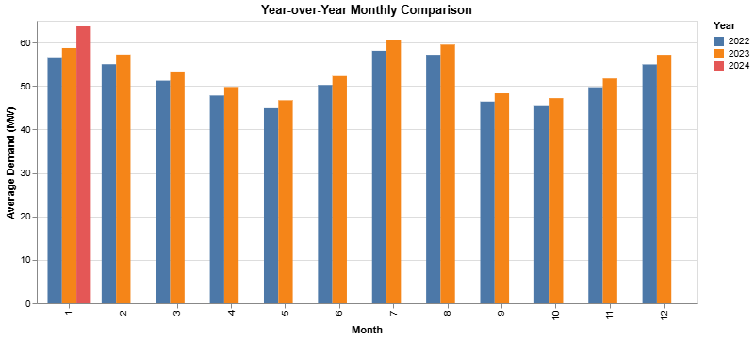
Figure 1: Monthly residential electric demand in MW from 2022 through Jan 2024 for Ann Arbor

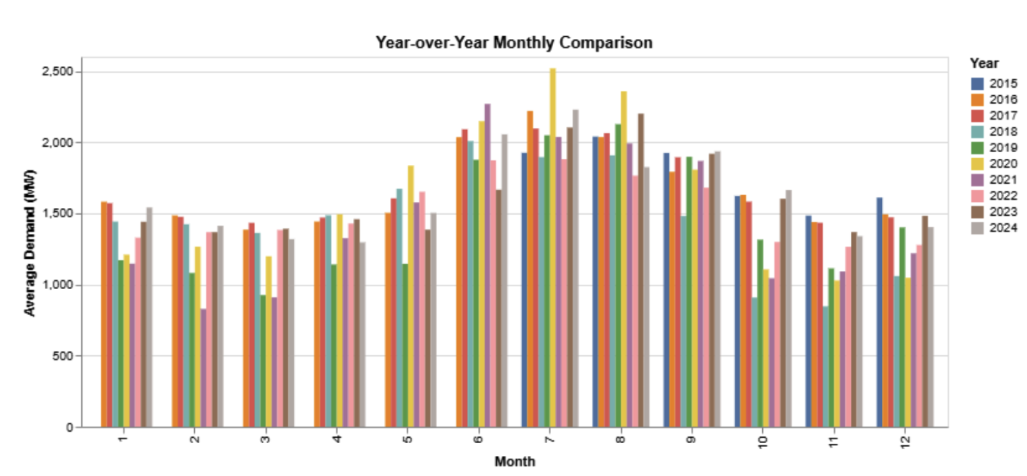
Figure 2: Monthly energy demand in MW from 2015 through 2024 for Tucson

The YOLO segmentation polygon-detection-derived roof areas were aggregated to produce a total amount of available rooftop area, per area being analyzed by the planner. This is key in assessing how much PV installation could be practically carried out. If the model is retrained with more labelled data, it could detect more sophisticated masks around the actual rooftop area that is available (ignoring existing PVs, skylights, shadowed areas, etc.). Based on the peak electric demand for Ann Arbor, the model results for Ann Arbor showed that 3.12e6 m² of available rooftop space with 8360 PV panels would be enough to meet the city’s current residential electricity demand. This amount of space would be enough to meet the projected electricity demand increase over the next 30 years. Due to the constraint of individual PV panels only being able to convert a modest amount of solar energy into electricity, meeting demand targets requires a large number of panels spread across many buildings in a city. The model results for Tucson showed that 1.85e6 m² of available rooftop space hosting 4.69e6 average PV panels would be enough to meet the city’s current electricity demand. Additionally, a growth rate of 0.0084% projected linearly shows that the available rooftop capacity would be able to meet the city’s demand for ~25 years.

The load durations curves for Ann Arbor and Tucson, shown below in Figure 3 and Figure 4, respectively, show the percentage of time when demand in each city reaches specific thresholds. Looking at the curves, you can see that demand for Tucson is at or below 50% of the city’s peak demand approximately 90% of the time, while Ann Arbor experiences a more stable load demand that is at or below 50% of the city’s peak demand approximately 50% of the time. These load duration curves are helpful for determining how fast to bring rooftop solar panels online, as roughly half of the solar panels needed to meet peak load in Tucson and Ann Arbor will be able to meet 100% of electricity demand in each city for 90% of the year and 50% of the year, respectively. This information can help city planning offices with lower budgets prioritize solar installation in a way that will optimize limited funding while still meeting system load requirements.
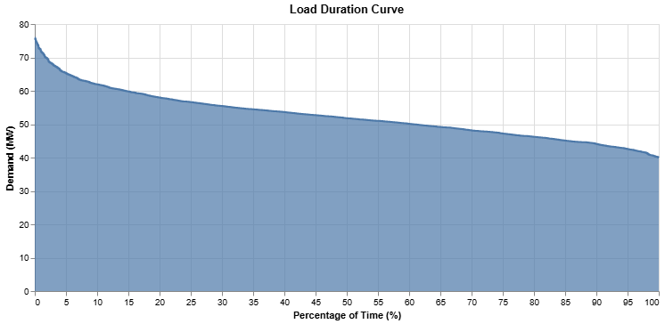
Figure 3: Load duration curve for Ann Arbor
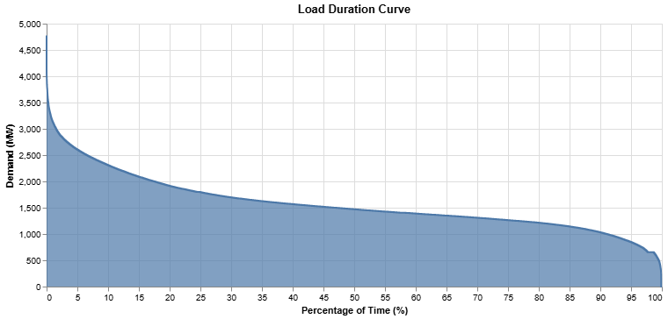
Figure 4: Load duration curve for Tucson

Figure 5 and Figure 6, below, translate the monthly and annual demand statistics for Ann Arbor and Tucson into the hourly patterns that rooftop PV panels and on-site storage will actually have to serve. Through showing average demand for every hour of a typical day in each season, these charts reveal when electricity use is highest (likely due to factors such as residential HVAC use and general appliance use in the hours before and after work) and when electricity use is the lowest (likely due to factors such as limited residential HVAC and appliance use during the workday). This exemplifies that while PV panel output, which generally peaks during the middle of the day when the sun is at its highest point in the sky, will likely align with the demand during some times of the day during certain seasons of the year but will not in other seasons, highlighting where additional demand-mitigating strategies like electric demand response and on-site solar storage are needed. The seasonal profiles also show how impactful the peaks are within each day (whether they are sharp spikes or more like plateaus), which affects how many panels and how much storage is required to meet those peaks. Together, these figures provide a temporal context for our rooftop PV potential estimates, and help to further illustrate why a large number of panels are needed to meaningfully affect city-wide demand patterns.
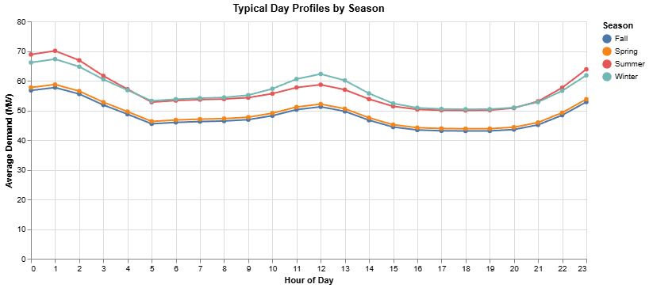
Figure 5: Average hourly electricity demand over each season for Ann Arbor

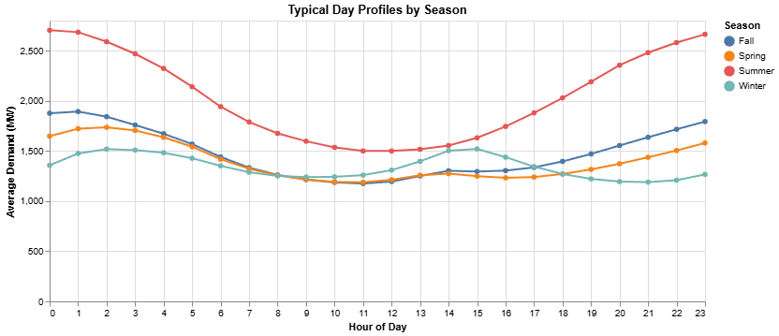
Figure 6: Average hourly electricity demand over each season for Tucson

Based on the number of PV panels needed to meet load needs in Ann Arbor and Tucson, the total cost for the panels will be approximately $9.35 Million and $524 Million, respectively. The average Residential rooftop solar installation timeline is about two to six months from initial planning through utility approval and permission to operate (Smith, 2024). Given this, using distributed rooftop solar as a solution to meeting electricity demand is both faster and less expensive than buildout of traditional electric generation facilities like gas-fired electric plants, which cost an average of $2,300 per W of capacity (roughly $84 Million and $4.7 Billion for Ann Arbor and Tucson’s electric generation needs, respectively) and take on average 3 years to build (Norton Rose Fulbright, 2025; U.S. Department of Energy, 2011), and electric transmission and distribution power lines from the gas-fired electric plan to homes, which cost an average of $3 million per mile of line and take an average of 8 years for completion from planning through construction (CTC Global, 2025; CA Public Advocates Office, 2023; American Clean Power Association, 2024).

Finally, while the current model only works for Ann Arbor and Tucson, our hope is that this tool can be expanded in the future to enable it to be used by city planning offices, particularly those that have limited funding for hiring technical experts to perform solar PV analyses for their city, which would require additional computing power and database capacity. This tool could be used by these city planning offices to quickly and easily determine their city’s current solar potential using only existing rooftops, aiding the city in planning ahead to meet future electric load growth in a way that is more cost-effective and faster to deploy than traditional electric infrastructure.

Broader Impacts and Ethical Considerations
This work will have a direct impact on both the citizens of Tucson and Ann Arbor, as well as the city planners for each city and the utility planning teams at the local electric utility. Through demonstrating how much load can be served by existing rooftops, our tool can help reduce the strain experienced by the grid during periods of extreme heat or cold, when demand spikes and the risk of blackouts and brownouts is highest. In practice, this means that rooftop PV is not only a decarbonization strategy, but also a resilience strategy as targeted deployment on high-value rooftops can help keep the lights on for households and critical facilities when the system is under stress. These benefits are especially important for vulnerable residents (i.e. low-income households, renters, and medically fragile customers) who are disproportionately harmed by outages and often have the fewest resources to cope with them.

Despite these benefits that will be experienced by all who live in a city who plans PV panel buildout using this tool, the ownership of the rooftop PV panels will introduce ethical concerns and the potential for creating burdens for households. For example, if the PV panels are household-owned and partially incentivized via utility or city funding, then a disparity will be created as low-income households will be less likely and less able to participate in a PV panel installation program. If instead the PV panels are utility-owned, then ethical concerns arise with the utility ownership and operation of PV assets on residential homes such as: utilities capturing most of the financial benefits while households assume hosting and aesthetic risks, limits on a household’s ability to modify or remove equipment installed on their roof, non-guaranteed unrestricted access to bill savings, and concerns about data privacy. If the identified optimal rooftops are primarily residential, then ethical considerations arise with relying on residential participation to meet electric capacity needs, and ensuring that these residential owners are properly compensated for the added value that their rooftop PV panels provide to the city or electric grid.

Statement of work
Our team took on responsibilities in the structure of a traditional Scrum (agile project management) team, where we took on equal and ever-evolving roles as our work on this project progressed. This ever-evolving workload ranged from each team member helping to label image data for model training purposes to team members working together to create CNN and YOLO models for image classification and evaluation.

References
- LaRiccia, D. (2025). Overview: Electricity consumption: Culture, gender and power. Energy History Online, Yale University. https://energyhistory.yale.edu/electricity-consumption-culture-gender-and-power/
- U.S. Energy Information Administration. (2025). Electricity use is becoming more common for residential heating. Today in Energy. https://www.eia.gov/todayinenergy/detail.php?id=66324
- O’Shaughnessy, E., & Shah, M. (2021). The demand-side opportunity: The roles of distributed solar and building energy systems in a decarbonized grid (NREL/TP-6A20-80527). National Renewable Energy Laboratory. https://www.nrel.gov/docs/fy21osti/80527.pdf
- Gagnon, P., Margolis, R., Melius, J., Phillips, C., & Elmore, R. (2016). Rooftop Solar Photovoltaic Technical Potential in the United States: NREL (National Renewable Energy Laboratory). https://www.nrel.gov/docs/fy16osti/65586.pdf
- Google. (2021). Project Sunroof [Web application]. Retrieved December 6, 2025, from https://sunroof.withgoogle.com/
- Lee, S., Iyengar, S., Feng, M., Shenoy, P. J., & Maji, S. (2019). DeepRoof: A data-driven approach for solar potential estimation using rooftop imagery. Proceedings of the 25th ACM SIGKDD International Conference on Knowledge Discovery & Data Mining, 2105–2113. https://arxiv.org/abs/2306.13564
- Goroshin, R., Wilson, A., Lamb, A., Peng, B., Ewonus, B., Rätsch, C., Raisher, J., Leung, M., Burq, M., Colthurst, T., Rucklidge, W., & Elkin, C. (2023). Estimating residential solar potential using aerial data. arXiv. https://arxiv.org/abs/2306.13564
- Ahmed, M. S., Arman, M. S., Tasnim, N., Imran, M. H., Sammak, M. H., & Bhuiyan, T. (2025). Rooftops detection with YOLOv8 from aerial imagery and a brief review on rooftop photovoltaic potential assessment. IAES International Journal of Artificial Intelligence, 14(3), 2282–2290. https://doi.org/10.11591/ijai.v14.i3.pp2282-2290
- Smith, J. (2024). How long does a solar panel installation take? SolarReviews. https://www.solarreviews.com/blog/solar-panel-installation-process
- Norton Rose Fulbright. (2025, August). The shift back to gas. Project Finance News. https://www.projectfinance.law/publications/2025/august/the-shift-back-to-gas/
- U.S. Department of Energy. (2011). Resource adequacy implications of forthcoming EPA air regulations (Technical report). https://www.energy.gov/
- CTC Global. (2025, September 25). Reducing the true cost of transmission line costs by voltage and the value of ACCC conductors. https://ctcglobal.com/reducing-the-true-cost-of-transmission-line-costs-by-voltage-and-the-value-of-accc-conductors/
- CA Public Advocates Office. (2023, June 12). Transmission project development timelines in California. California Public Utilities Commission. https://www.publicadvocates.cpuc.ca.gov/
- American Clean Power Association. (2024, April). U.S. permitting delays hold back economy, cost jobs (Fact sheet). https://cleanpower.org/
- Wyent, C., Verma, M., & Kanj, W. (2025). Homegrown energy: How household upgrades can meet 100 percent of data center demand growth. Rewiring America. https://www.rewiringamerica.org/research/homegrown-energy-report-ai-data-center-demand
- Molnár, Gergely & Cabeza, Luisa F. & Chatterjee, Souran & Ürge-Vorsatz, Diana. (2024). Modelling the building-related photovoltaic power production potential in the light of the EU's Solar Rooftop Initiative. Applied Energy. 360. 10.1016/j.apenergy.2024.122708. https://www.researchgate.net/publication/378012189_Modelling_the_building-related_photovoltaic_power_production_potential_in_the_light_of_the_EU's_Solar_Rooftop_Initiative
- Kishore, Aparna & Thorve, Swapna & Marathe, Madhav. (2024). A Generative AI Technique for Synthesizing a Digital Twin for U.S. Residential Solar Adoption and Generation. 10.48550/arXiv.2410.08098. https://www.researchgate.net/publication/384812331_A_Generative_AI_Technique_for_Synthesizing_a_Digital_Twin_for_US_Residential_Solar_Adoption_and_Generation
- Barrera, N. A. G., González, D. C. P., Mesa, F., & Aristizábal, A. J. (2021). Procedure for the practical and economic integration of solar PV energy in the city of Bogotá. Energy Reports, 7, 163–180. https://doi.org/10.1016/j.egyr.2021.08.091
- Dragne, H. G., & Iordache, F. (2019). Determining the coverage levels of solar installations for romania. Construcţii (București), 20(1/2), 65–69.
https://research-ebsco-com.proxy.lib.umich.edu/c/mqk2bj/viewer/pdf/gna63vdoov?route=details
- Lan, H., Gou, Z., & Lu, Y. (2021). Machine learning approach to understand regional disparity of residential solar adoption in Australia. Renewable & Sustainable Energy Reviews, 136, 110458-. https://doi.org/10.1016/j.rser.2020.110458
- Jakubiec, J. A., & Reinhart, C. F. (2013). A method for predicting city-wide electricity gains from photovoltaic panels based on LIDAR and GIS data combined with hourly Daysim simulations. Solar Energy, 93, 127–143. https://doi.org/10.1016/j.solener.2013.03.022
- Chen, Y., Hong, T., Luo, X., & Hooper, B. (2019). Development of city buildings dataset for urban building energy modeling. Energy and Buildings, 183, 252–265. https://doi.org/10.1016/j.enbuild.2018.11.008
- El Kontar, R., & Jin, X. (2020). A Framework for Optimal Placement of Rooftop Photovoltaic: Maximizing Solar Production and Operational Cost Savings in Residential Communities. ASME Journal of Engineering for Sustainable Buildings and Cities, 1(4). https://doi.org/10.1115/1.4049135

Appendix
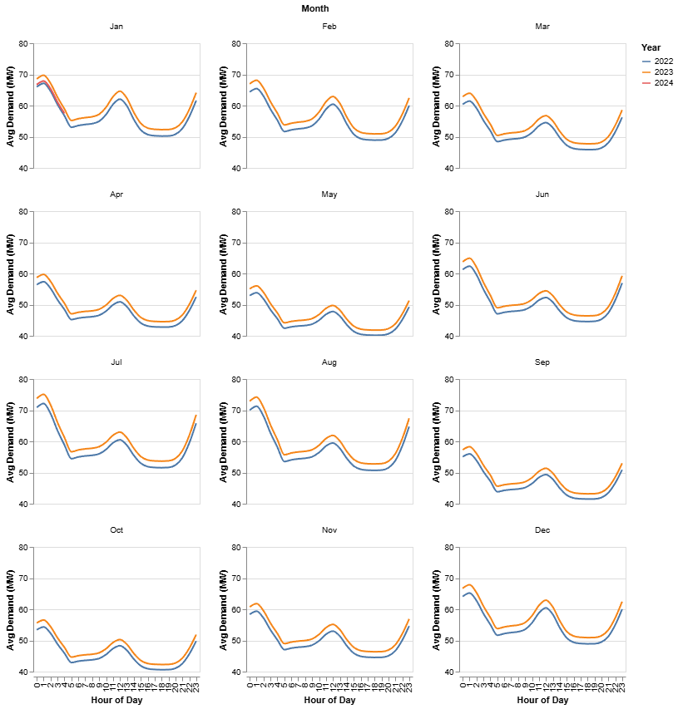
Appendix Figure 1: Average hourly electricity demand over each month for Ann Arbor
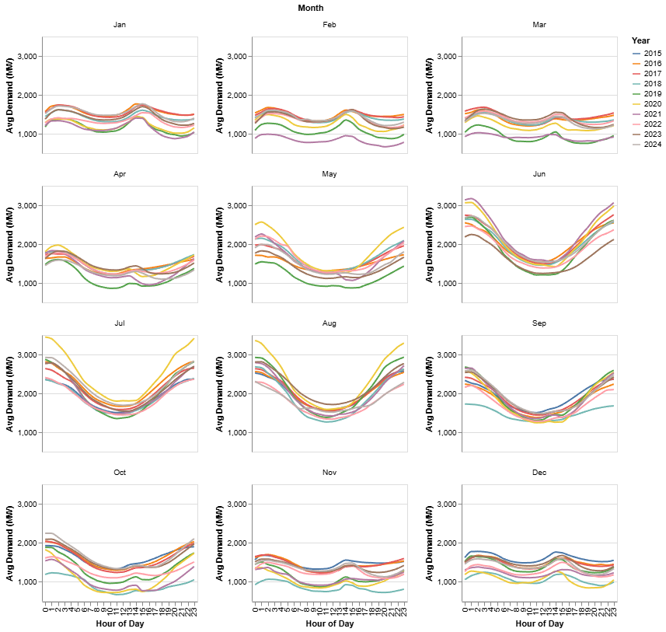
Appendix Figure 2: Average hourly electricity demand over each month for Tucson

Learning Rate | Batch Size | Weight Decay | Optimizer | Mean Validation Loss | Std Validation Loss | Mean Accuracy
 |  |  |  |  |  | Has roof | R/C | PV | Azimuth
0.0001 | 32 | 0.0001 | adam | 5.92 | 0.40 | 74.36 | 60.66 | 93.73 | 97.32
0.0001 | 64 | 0.001 | adam | 5.97 | 0.44 | 74.48 | 60.47 | 93.73 | 97.32
0.0005 | 64 | 0.0001 | sgd | 5.99 | 0.34 | 74.66 | 59.68 | 93.97 | 97.38
0.0005 | 64 | 0.0001 | adam | 6.00 | 0.57 | 74.97 | 62.18 | 93.91 | 97.38
0.001 | 64 | 0.001 | sgd | 6.00 | 0.36 | 75.58 | 61.21 | 93.54 | 97.38
0.0005 | 64 | 1.00E-05 | adam | 6.01 | 0.54 | 75.22 | 63.58 | 93.73 | 97.32
0.0001 | 64 | 1.00E-05 | adam | 6.04 | 0.38 | 75.46 | 61.21 | 93.73 | 97.32
0.0005 | 32 | 0.0001 | adam | 6.05 | 0.29 | 73.75 | 62.30 | 94.09 | 97.32
0.0001 | 32 | 0.001 | adam | 6.05 | 0.46 | 75.09 | 61.57 | 93.79 | 97.32
0.0001 | 64 | 0.0001 | adam | 6.05 | 0.26 | 75.28 | 60.11 | 93.79 | 97.26
0.0005 | 64 | 1.00E-05 | sgd | 6.09 | 0.33 | 73.51 | 60.23 | 93.91 | 97.38
0.001 | 64 | 1.00E-05 | sgd | 6.11 | 0.32 | 74.42 | 59.74 | 93.79 | 97.38
0.0005 | 64 | 0.001 | sgd | 6.11 | 0.33 | 73.63 | 58.89 | 93.85 | 97.38
0.0005 | 64 | 0.001 | adam | 6.12 | 0.59 | 76.98 | 64.01 | 93.67 | 97.26
0.0001 | 32 | 1.00E-05 | adam | 6.12 | 0.38 | 75.46 | 60.29 | 93.85 | 97.32
0.001 | 64 | 0.0001 | adam | 6.13 | 0.42 | 74.00 | 59.56 | 93.55 | 97.38
0.001 | 64 | 0.0001 | sgd | 6.19 | 0.34 | 76.19 | 61.02 | 93.79 | 97.26
0.0005 | 32 | 1.00E-05 | adam | 6.21 | 0.60 | 74.91 | 62.30 | 93.79 | 97.32
0.001 | 32 | 0.0001 | adam | 6.22 | 0.48 | 73.51 | 59.68 | 93.67 | 97.38
0.001 | 64 | 0.001 | adam | 6.26 | 0.44 | 74.67 | 60.84 | 92.75 | 97.38
0.001 | 64 | 1.00E-05 | adam | 6.26 | 0.64 | 72.78 | 59.38 | 93.73 | 97.38
0.0005 | 32 | 1.00E-05 | sgd | 6.27 | 0.54 | 73.51 | 60.90 | 93.67 | 97.32
0.0005 | 32 | 0.0001 | sgd | 6.27 | 0.43 | 74.06 | 60.41 | 93.18 | 97.38
0.0005 | 32 | 0.001 | sgd | 6.29 | 0.53 | 74.97 | 59.32 | 93.36 | 97.38
0.0005 | 32 | 0.001 | adam | 6.35 | 0.53 | 73.75 | 60.84 | 93.48 | 97.26
0.001 | 32 | 1.00E-05 | adam | 6.37 | 0.37 | 73.32 | 56.03 | 92.51 | 97.26
0.0001 | 32 | 0.001 | sgd | 6.37 | 0.32 | 72.11 | 56.33 | 93.85 | 97.38
0.0001 | 32 | 1.00E-05 | sgd | 6.43 | 0.45 | 71.86 | 54.75 | 93.91 | 97.38
0.0001 | 64 | 1.00E-05 | sgd | 6.45 | 0.38 | 70.58 | 52.19 | 93.85 | 97.38
0.0001 | 32 | 0.0001 | sgd | 6.47 | 0.53 | 69.85 | 51.27 | 93.91 | 97.38
0.001 | 32 | 0.001 | adam | 6.48 | 0.57 | 73.81 | 58.22 | 92.51 | 97.02
0.001 | 32 | 0.001 | sgd | 6.48 | 0.43 | 75.88 | 61.02 | 93.30 | 97.38
0.001 | 32 | 0.0001 | sgd | 6.49 | 0.22 | 74.54 | 60.78 | 93.91 | 97.32
0.0001 | 64 | 0.001 | sgd | 6.50 | 0.46 | 67.97 | 51.22 | 93.97 | 97.38
0.001 | 32 | 1.00E-05 | sgd | 6.52 | 0.65 | 73.27 | 57.73 | 93.48 | 97.38
0.0001 | 64 | 0.0001 | sgd | 6.59 | 0.50 | 67.91 | 49.70 | 93.97 | 97.38

Appendix Figure 3. Grid search cross validation results for CNN model (sorted from top to bottom)

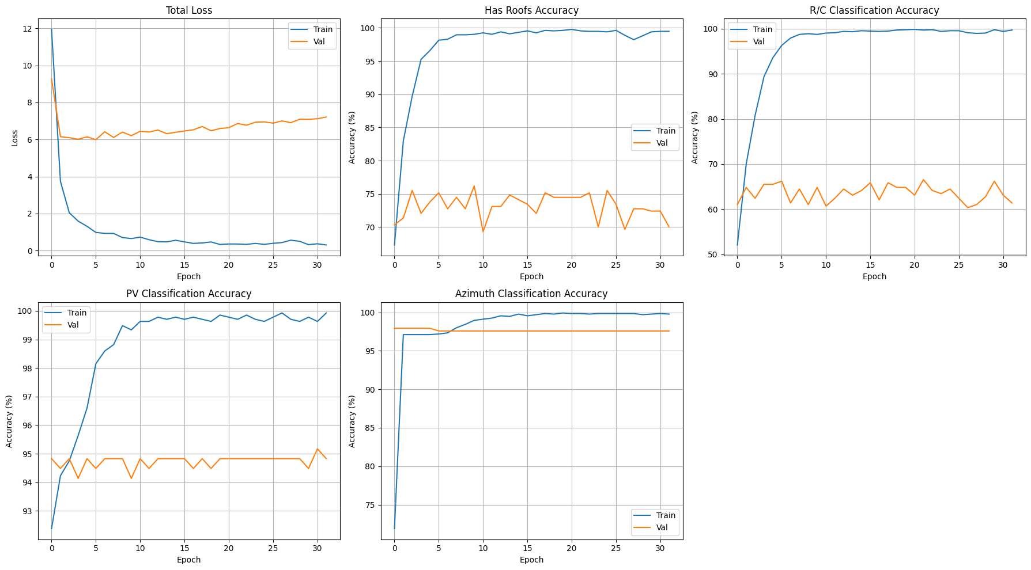
Appendix Figure 4. Total loss and accuracy per feature with CNN using grid search optimal results

 | Brand | VSUN | REC | Qcells | Canadian Solar | Jinko | Hyundai Energy Solutions | Silfab | Sirius Solar | Trina Solar
Model | Maxeon 6 | VSUN 490N | Alpha Pure | Q.TRON BLK M-G2+ | TOPHiKu6 | Tiger Neo | HiN-T435NF(BK) | Prime NTC | MBB HC | 435W
Efficiency | 22.80% | 22.65% | 22.20% | 22.50% | 22% | 22.02% | 22.23% | 22.10% | 21.25% | 21.80%
Power | 440 W | 490 W | 410 W | 440 W | 450 W | 440 W | 435 W | 430 W | 415 W | 435 W
Panel Size | 20.79 sq. ft. | 23.3 sq. ft | 19.91 sq. ft. | 21.02 sq. ft. | 21.97 sq. ft. | 21.51 sq. ft. | 21 sq. ft. | 20.99 sq. ft. | 21.02 sq.ft | 21.51 sq. ft.
Power per sqft | 21.16 W/sq. ft. | 21 W/sq. ft | 20.59 W/sq. ft. | 20.93 W/sq. ft. | 20.48 W/sq. ft. | 20.46 W/sq. ft. | 20.7 W/sq. ft. | 21 W/sq. ft. | 19.7 W/sq. ft. | 20.2 W/sq. ft.
Temperature coefficient (°C) | -0.29%/°C | -0.30%°C | -0.26%/°C | -0.30%/°C | -0.29%/°C | -0.29%/°C | -0.30%/°C | -0.30%/°C | -0.30%/°C | -0.30%/°C
Product warranty | 40 years | 25 years | 25 years | 25 years | 25 years | 30 years | 25 years | 25 years | 25 years | 25 years
Performance warranty (25yr) | 92% | - | 92% | 90.60% | 89.40% | 89.40% | - | 90.80% | - | 89%
Performance warranty (30yr) | - | 87.40% | - | - | 87.40% | 87.40% | 87.40% | 89.30% | 87.20% | -
Average cost per watt | $2.84 | $2.43 | $2.53 | $2.48 | $2.73 | $2.82 | $2.53 | $2.67 | $2.13 | $2.33
Value (W/sq ft/$/W) | 7.45 | 9.59 | 8.2 | 8.44 | 8.05 | 7.26 | 8.18 | 7.86 | 9.25 | 8.67

Appendix Figure 5. Most highly rated PV companies and models (US available)

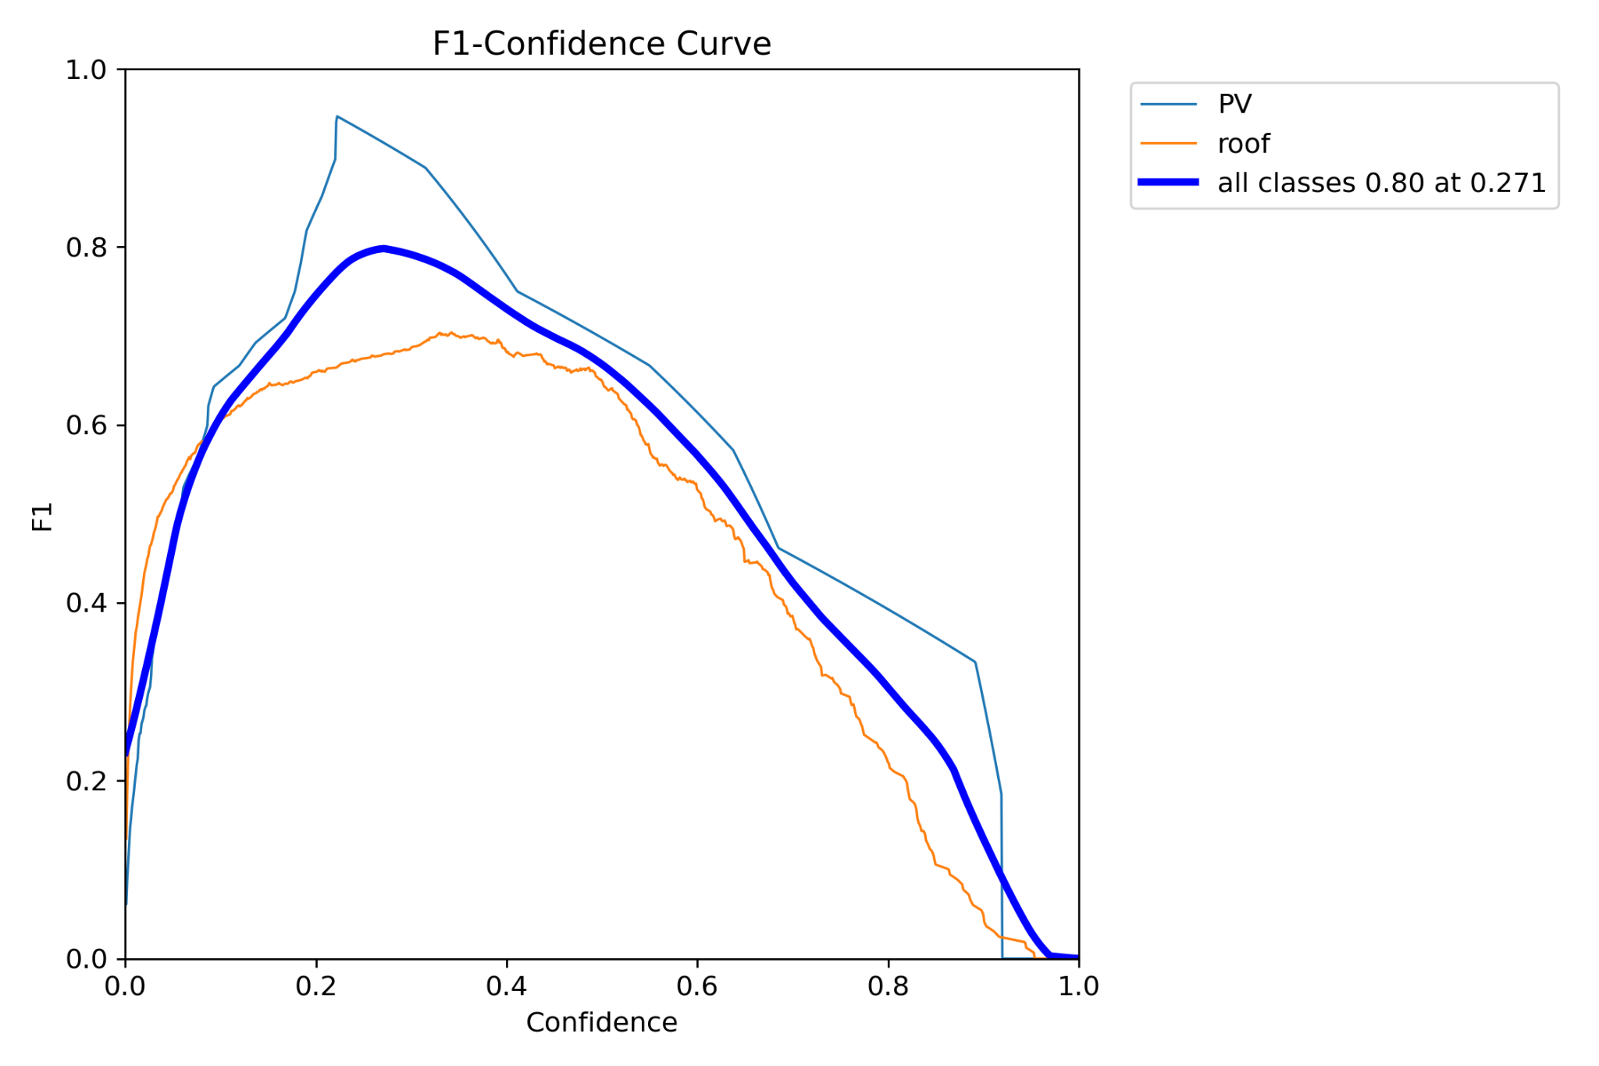
Appendix Figure 6: Polygon YOLO F1-Confidence Curve

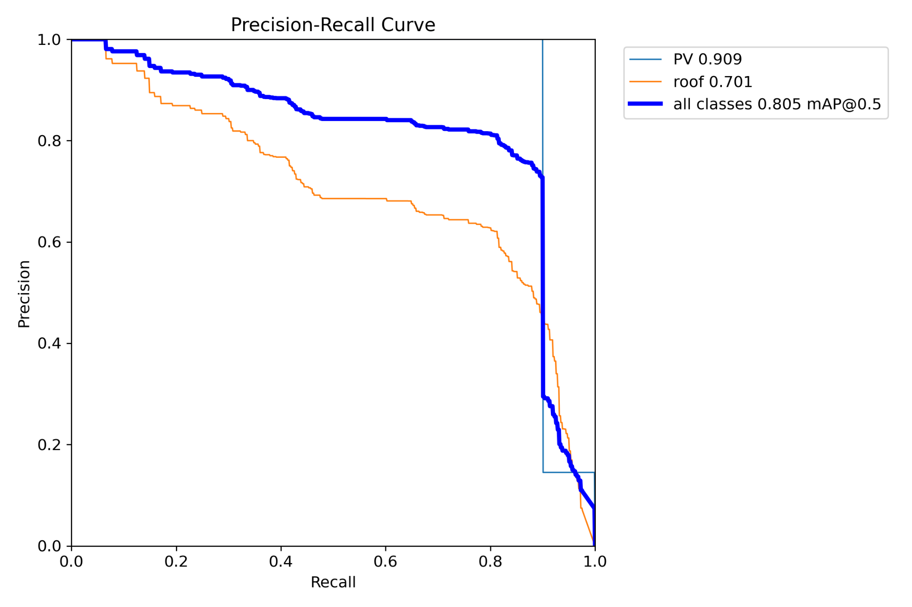
Appendix Figure 7: Polygon YOLO RC Curve
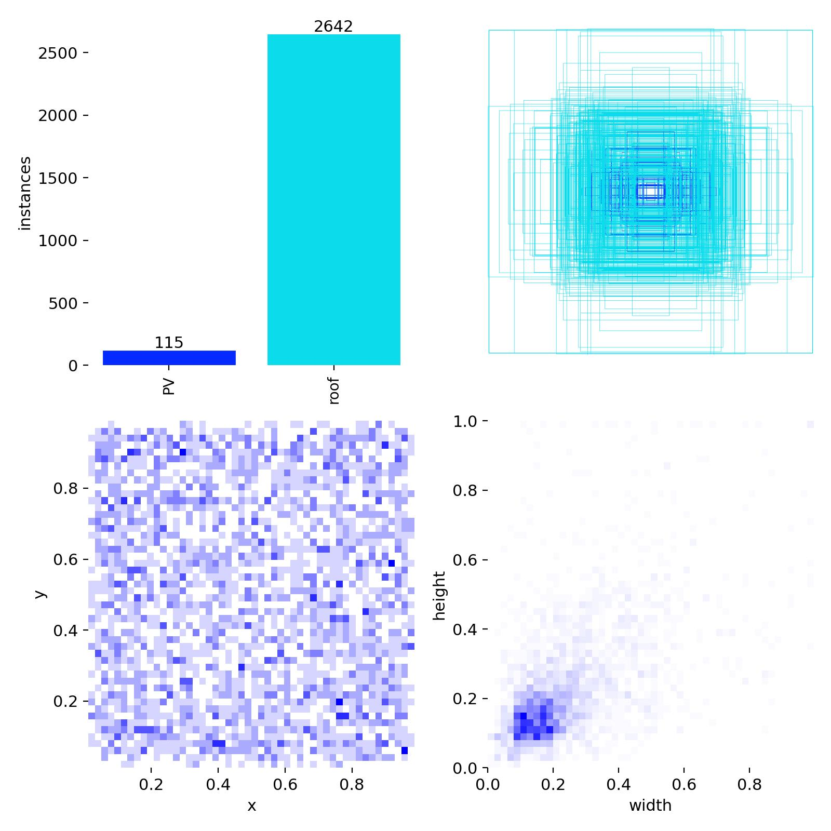
Appendix Figure 8: Polygon YOLO Labels
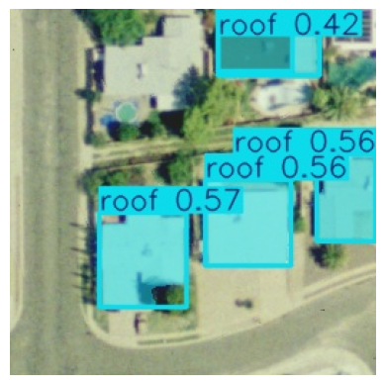
Appendix Figure 9. YOLO Polygon Mask Detection of Roofs, Inference Image, Ann Arbor

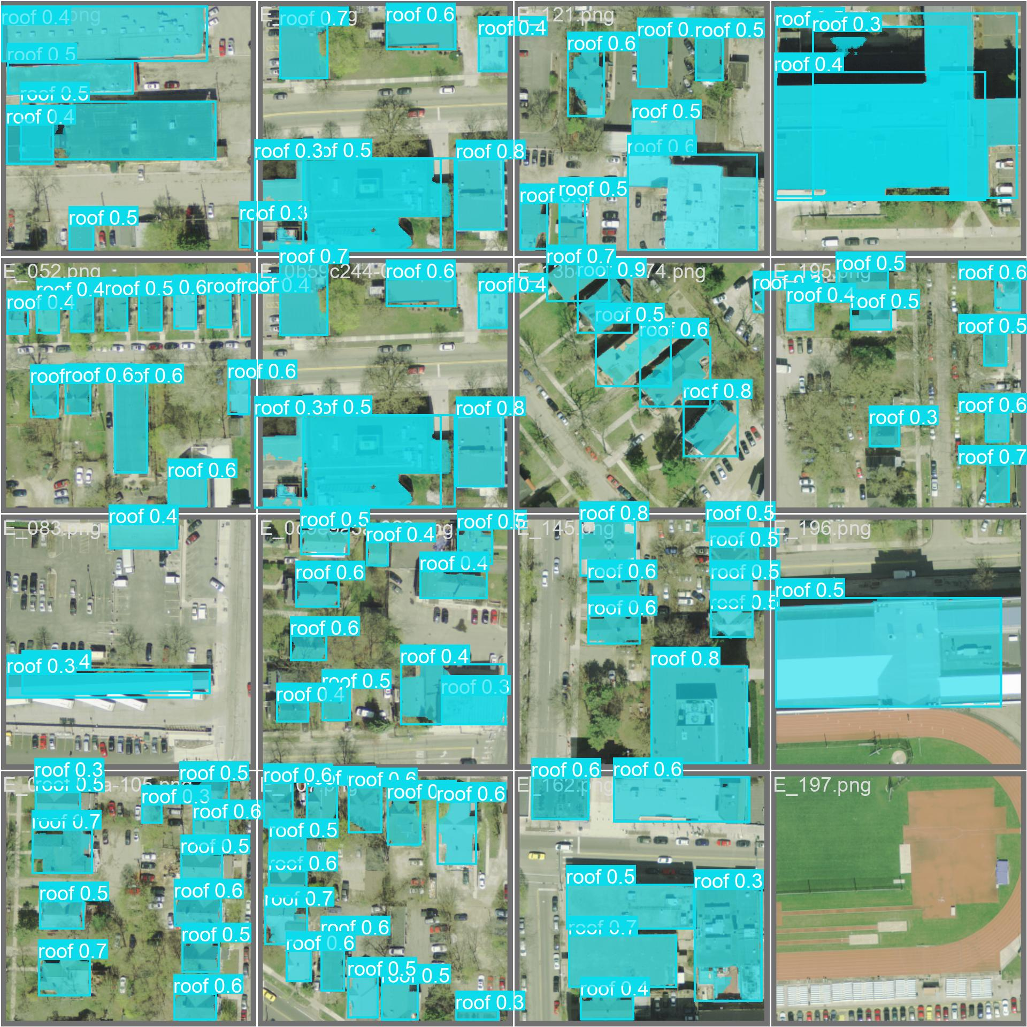
Appendix Figure 10. YOLO Polygon Segmented Masks, Validation Batch 1, Ann Arbor

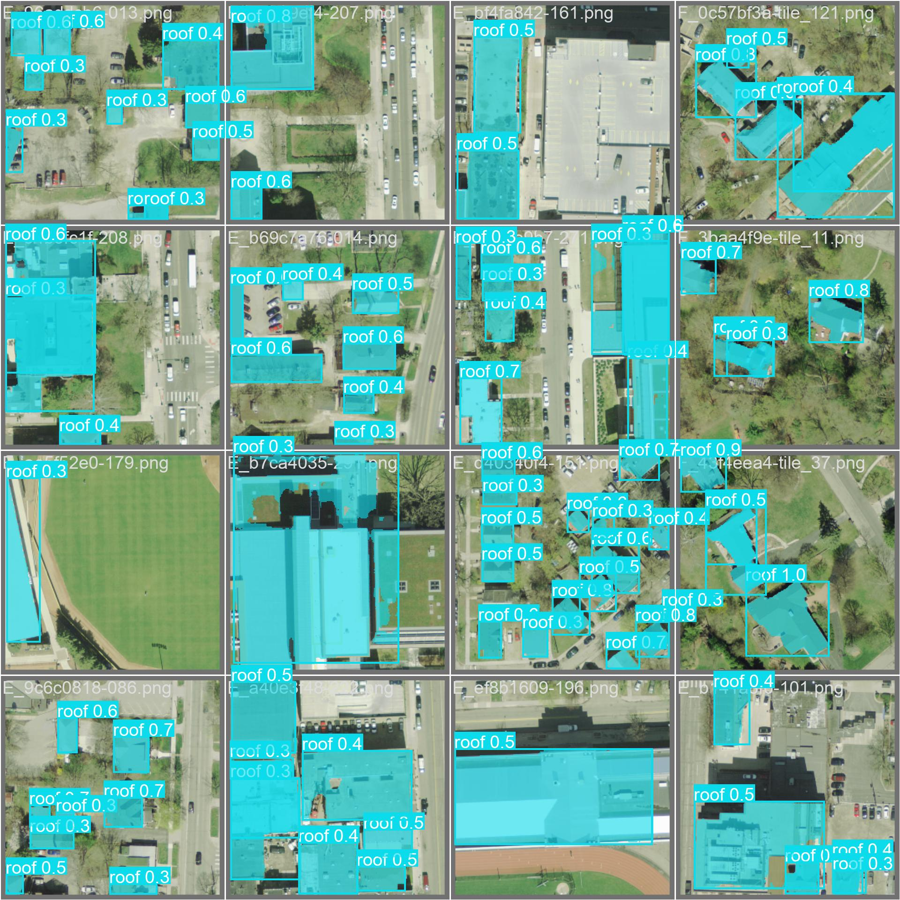
Appendix Figure 11. YOLO Polygon Segmented Masks, Validation Batch 2, Ann Arbor

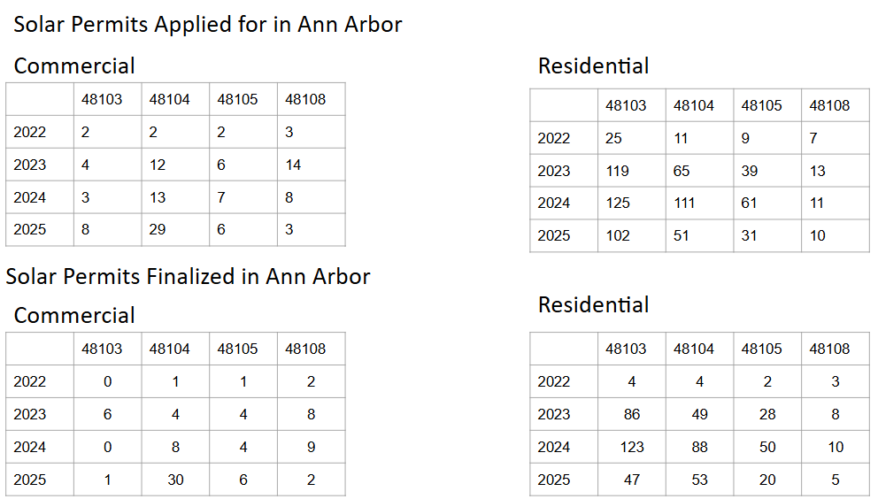
Appendix Fig 12. Residential and Commercial Solar Permits for Ann Arbor
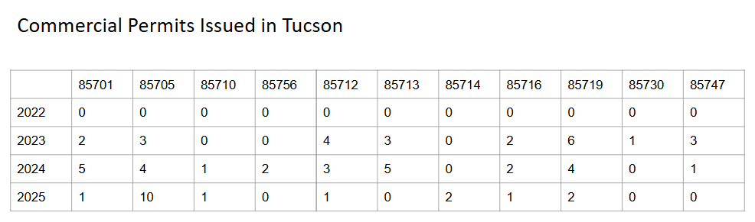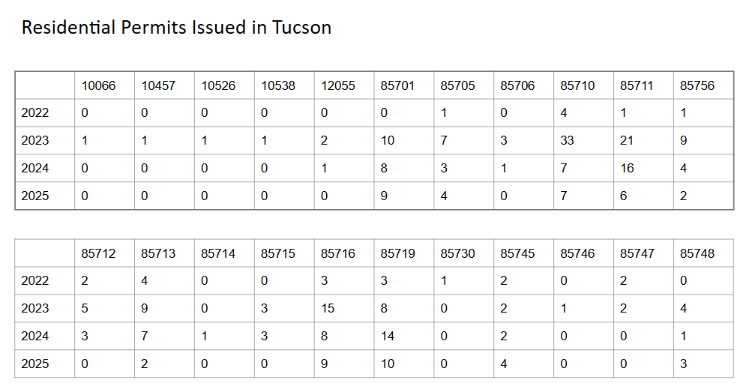
Appendix Fig 13. Residential and Commercial Solar Permits for Tucson

This information obtained from coordinate reference system (“CRS”) projection metadata embedded in GeoTIFF (georeferenced TIFF) files, accessed using QGIS (an open-source geographic information system).
Note: More years of historic electric demand data were available for Tucson than Ann Arbor, hence the difference between the years illustrated in Figure 1 and Figure 2
These metrics are based on leading PV panel manufacturer data, including from companies such as Maxeon, VSUN, REC, Qcells, Canadian Solar, Jinko, Hyundai Energy Solutions, Silfab, Sirius Solar, and Trina Solar (not inclusive of labor and installation costs, or potential wholesale savings amounts)
Note: Due to the limited availability of accessible data, Ann Arbor electric demand, and the resulting estimated number of PVs to meet the peak, is limited to residential demand data only. More accessible data for Tucson was available, so the demand amounts are reflective of residential, commercial, and industrial loads.

